**TECHNOLOGICAL INSTITUTE OF THE PHILIPPINES**

938 Aurora Blvd. Cubao, Quezon City

**COLLEGE OF INFORMATION TECHNOLOGY EDUCATION**

**Project:** **Developing E-Commerce Website using HTML5 and CSS**

The Digital Era

In Partial Fulfilment of the Requirements for

ITE 011– Introduction to Computing

by:

Luzana, Emmanuelle Angelo / BSECE

Membreve, Jayson Dale / BSECE

Olarte, Joziah James / BSECE

Ramilo, Kim Jay / BSECE

Salem, Joaquin Dominic / BSECE

Tolosa, Earl Justin / BSECE

Ms. Arceli F. Salo

Instructor

May 2025

**Company Background**



Founded by Luzana, Membreve, Olarte, Ramilo, and Salem in May 2025, **The Digital Renaissance of Learning** is a hub designed to bridge the gap between education and technology. As the world rapidly shifts toward digital transformation, this platform serves as a guide for students, educators, and tech enthusiasts to embrace the power of Information Technology Education (ITE).

Our goal is to empower students, educators, and tech enthusiasts by providing innovative learning tools, industry insights, and cutting-edge resources.

As for the progress of founding the company, the team took care of the mockup designs and managed to set up the code of the webpage, and made sure that most of the primary objectives of the company’s overall setup were met.

**Products**

Books: ₱1250.00 per book, ₱4000.00 for Full Series. (these are just mockups)

* Automation
* Internet
* Education
* Technology

**Screenshots:**

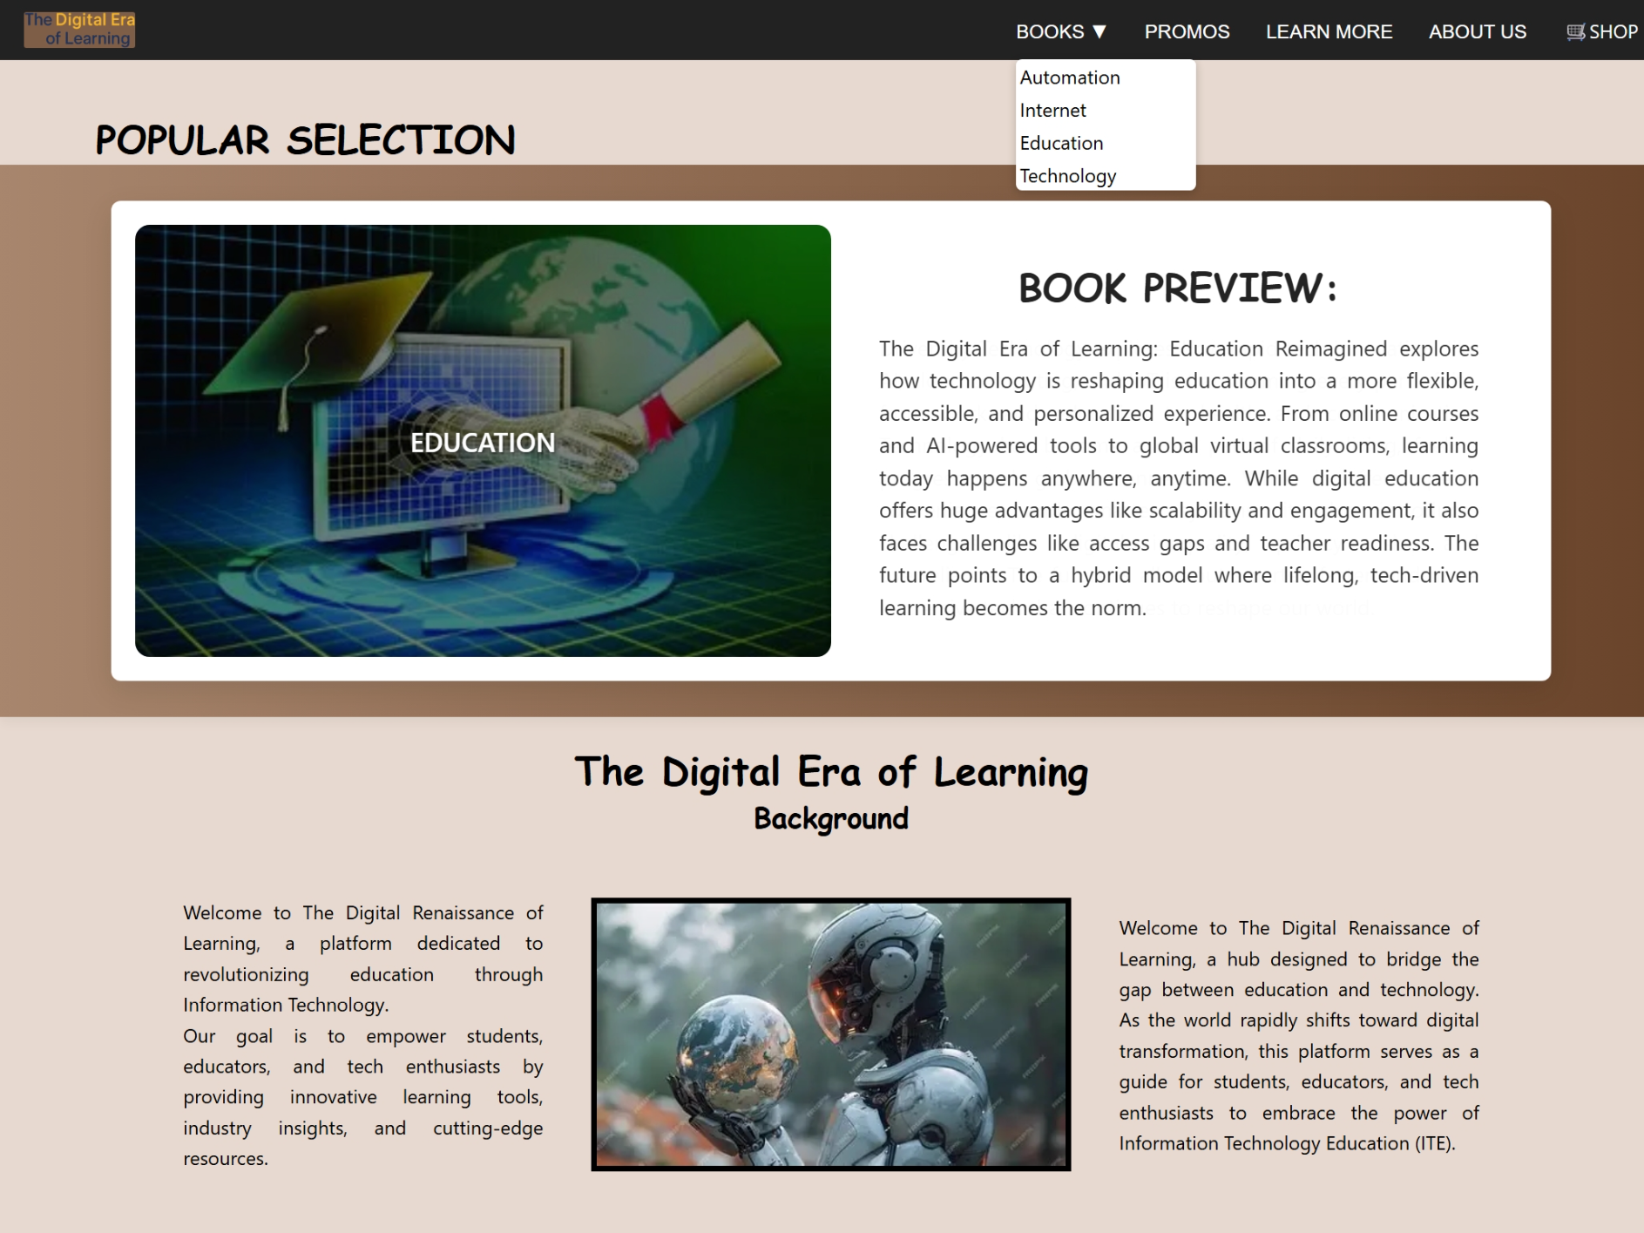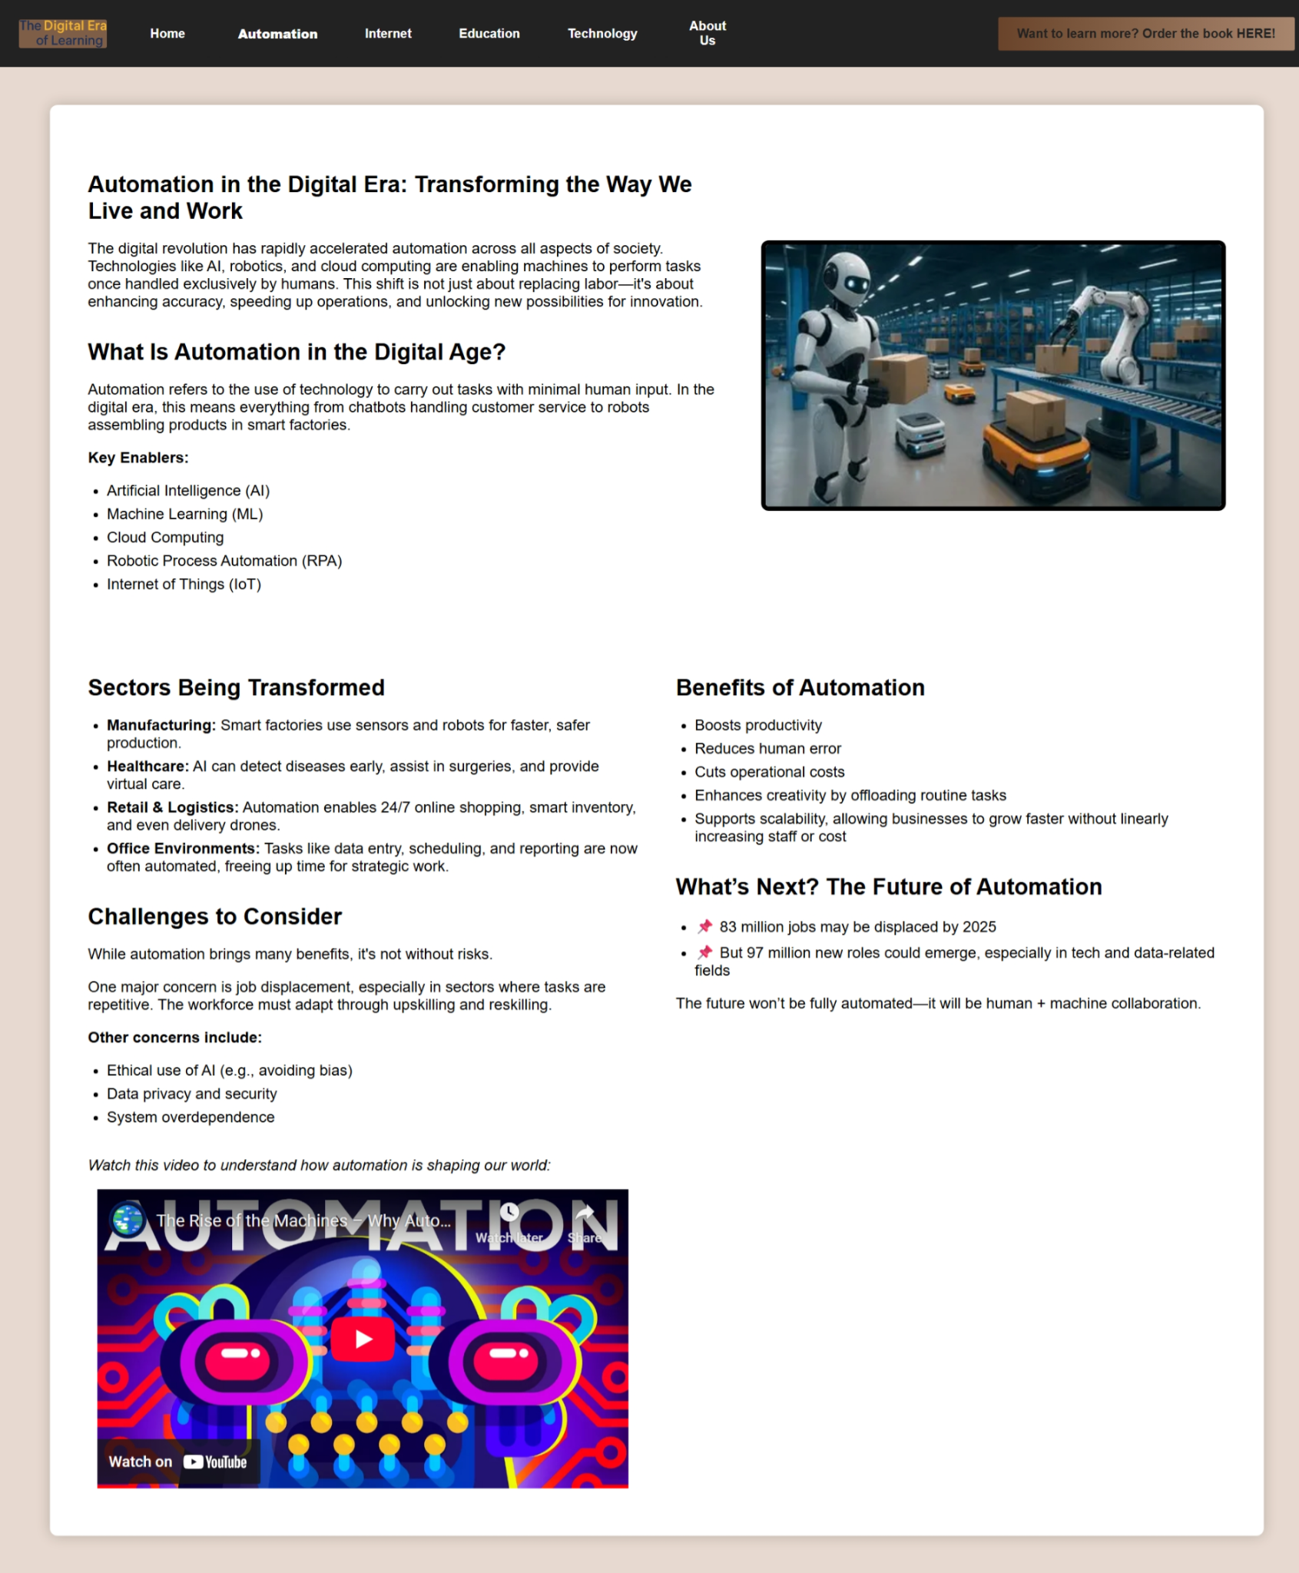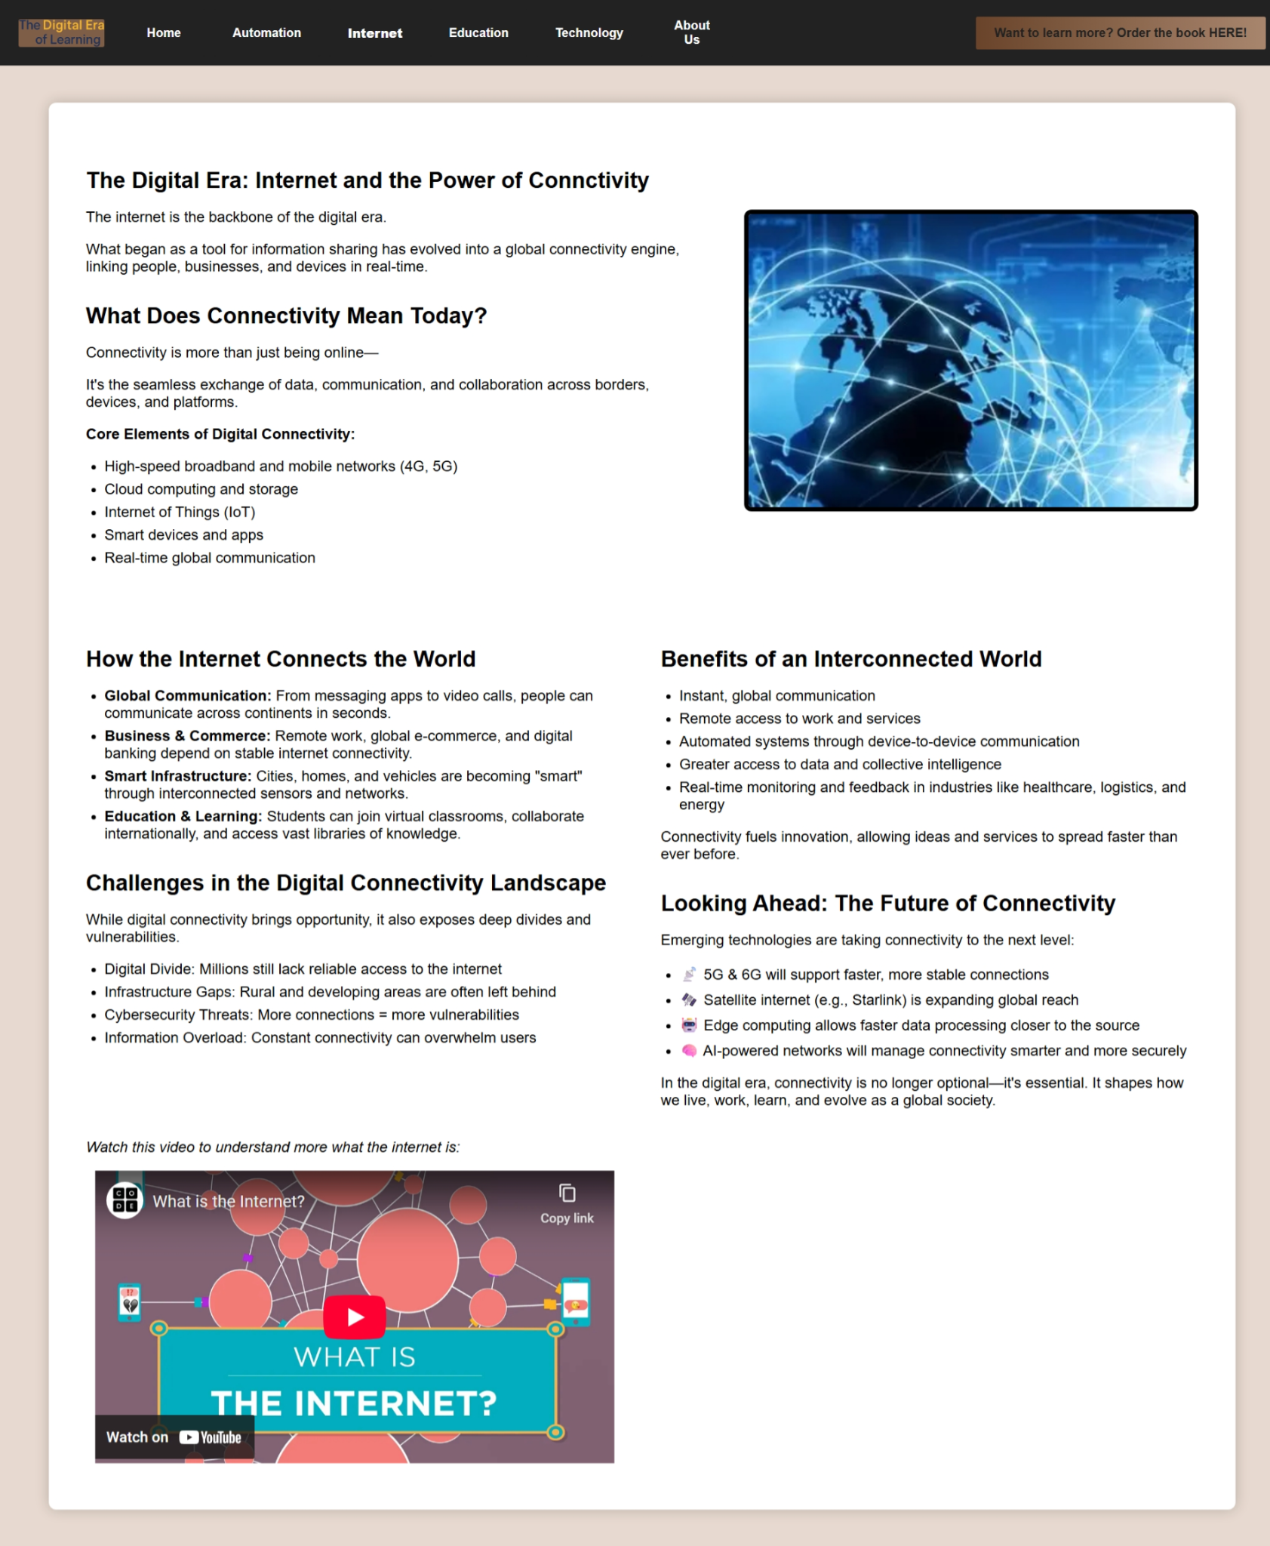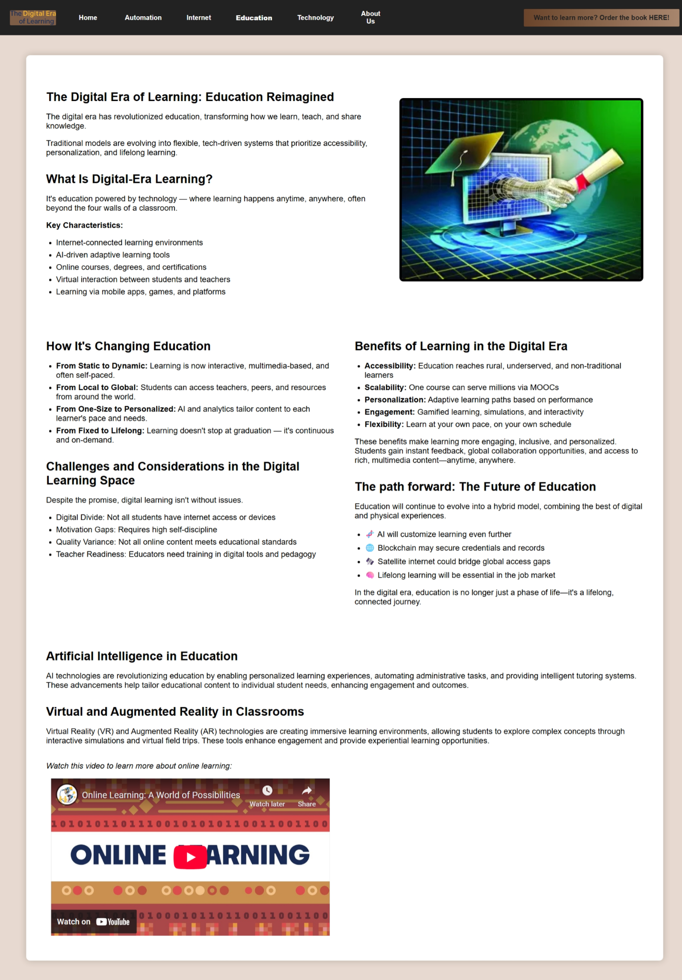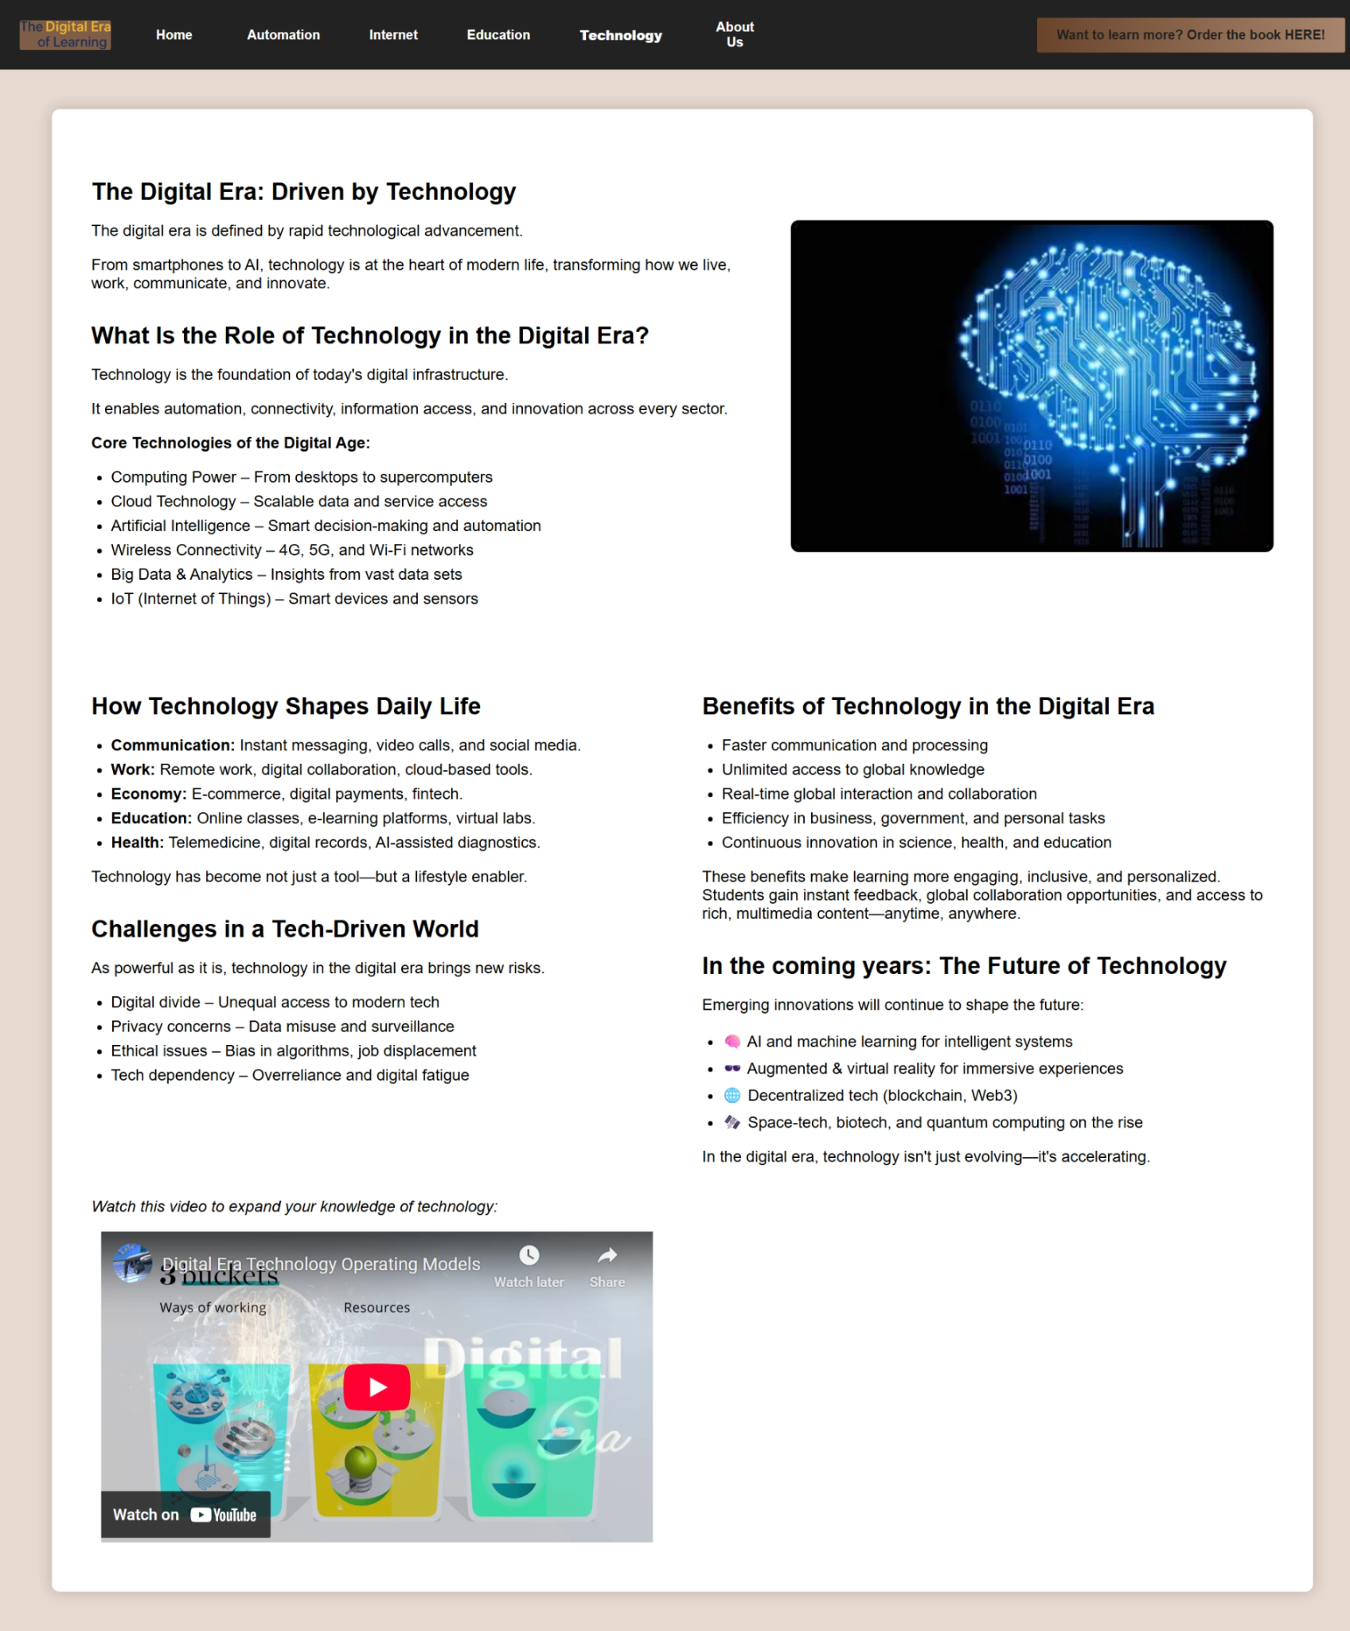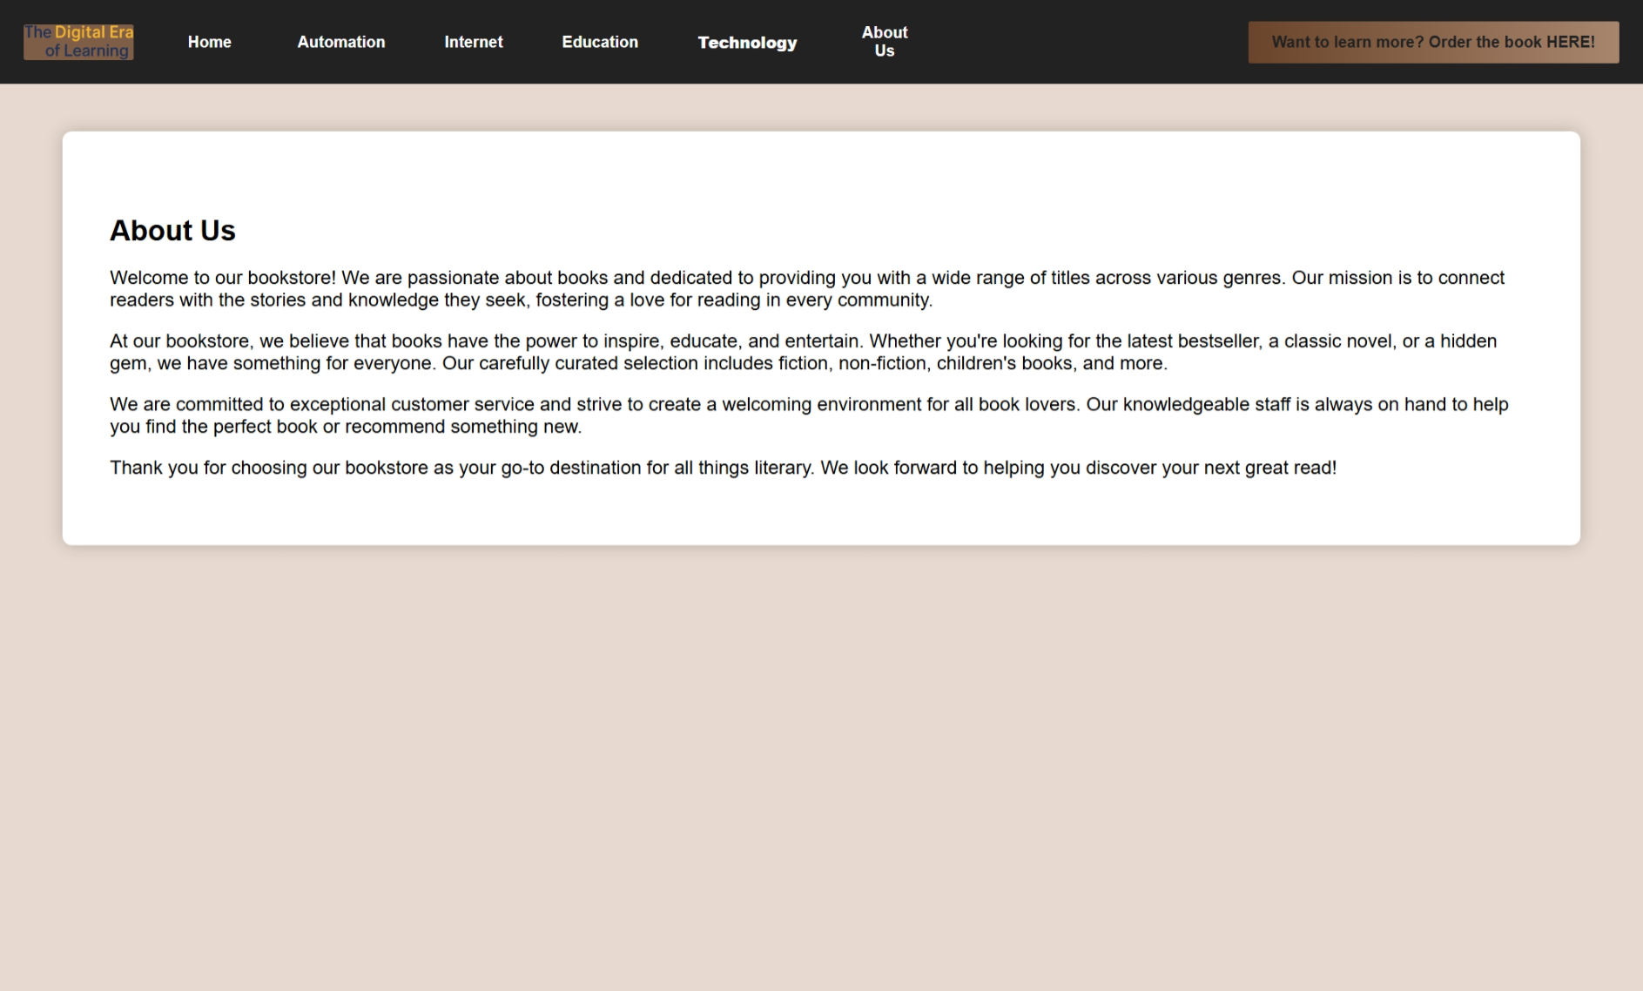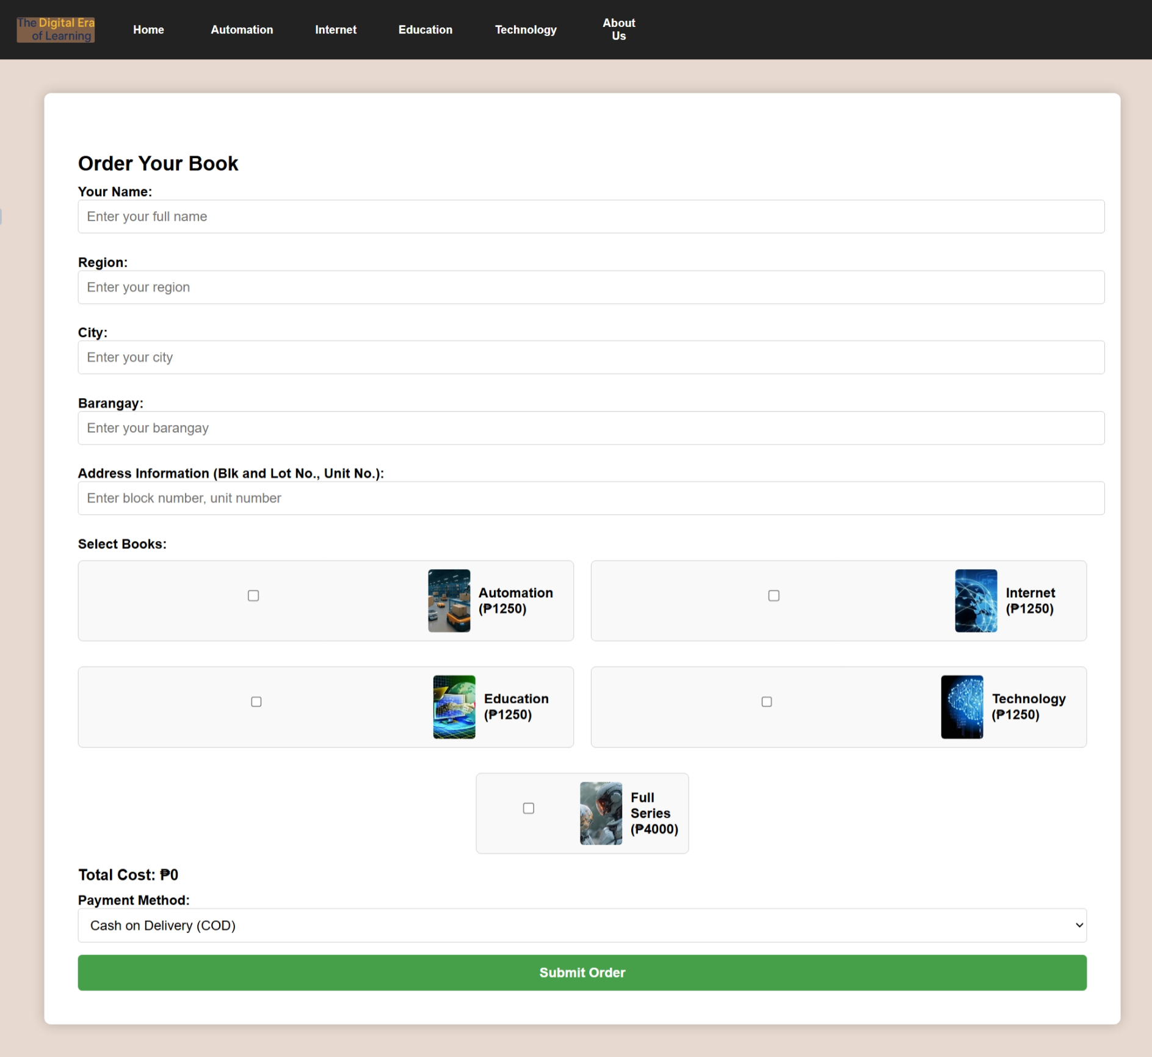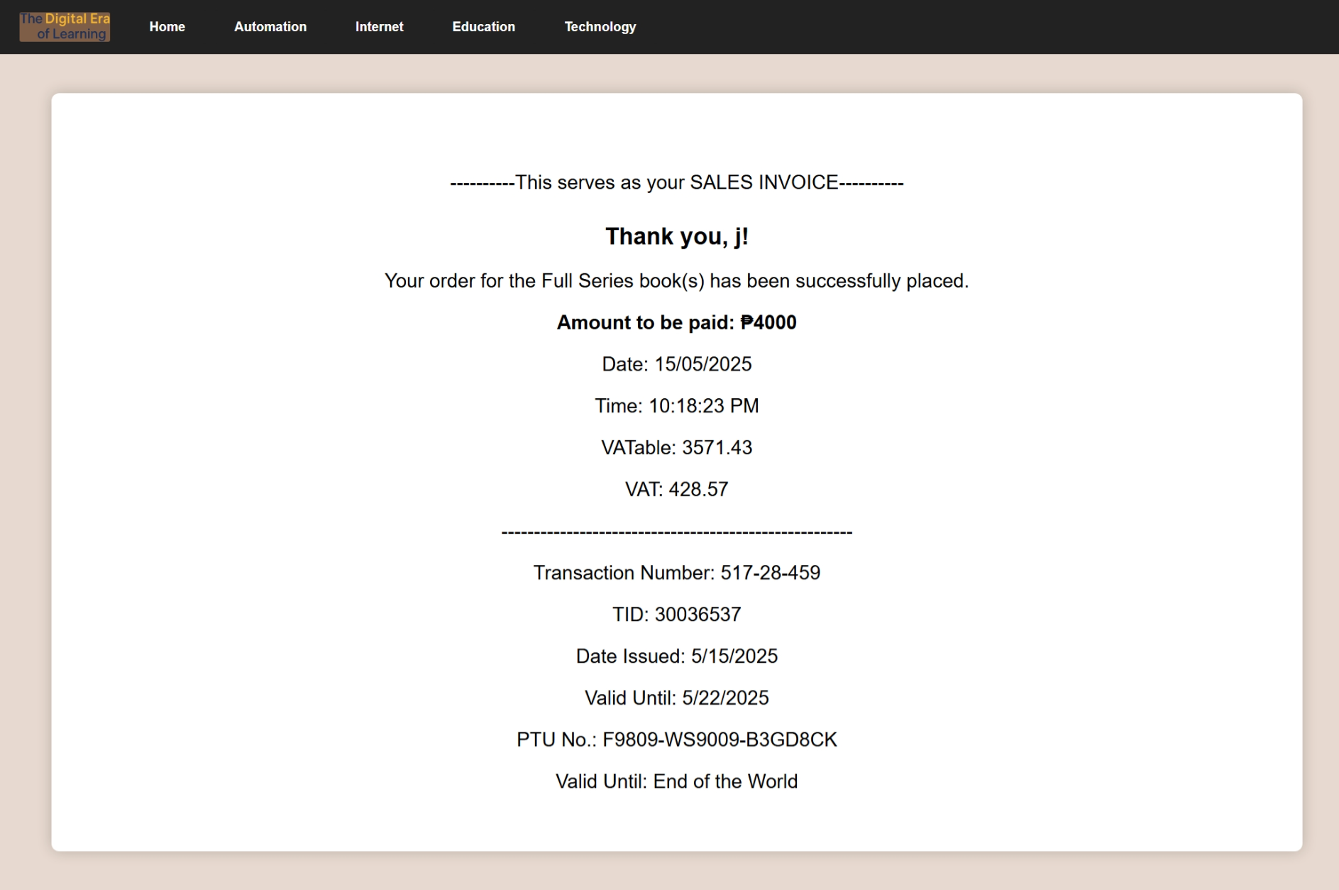

**References:**

* **GitHub Code Repository:** <https://github.com/EALuzana/ITE/>
* **GitHub Code History:** <https://github.com/EALuzana/ITE/commits/main/>
* **Videos used in the website:**
  + <https://www.youtube.com/watch?v=WSKi8HfcxEk&t=88s>
  + <https://www.youtube.com/watch?v=Dxcc6ycZ73M>
  + <https://www.youtube.com/watch?v=TcOEt6TdoYQ>
  + <https://www.youtube.com/watch?v=jGWLsQCYQtw>

**Documentation:**

| **File Names & Pictures** | |
| --- | --- |
| **HTML** | **CSS** |
| **brain.html**  <head>  <title>Automation in the Digital Era</title>  <!-- Ramilo, Kim Jay -->  <link rel="stylesheet" href="$content.css" />  <link rel="stylesheet" href="$nav-styles.css" />  <link rel="stylesheet" href="$logo.css" />  </head> | Integrated files:  **$content.css**  **$nav-styles.css**  **$logo.css** |
|  | |
| **robot.html**  <div>  <!-- Tolosa, Earl Justin -->  <p><i> Watch this video to understand how automation is shaping our world: </i></p>  <iframe class="video-container" src="https://www.youtube.com/embed/WSKi8HfcxEk?si=Uk0zrZGQTrqfaR0Q"  title="YouTube video player" frameborder="0"  allow="accelerometer; autoplay; clipboard-write; encrypted-media; gyroscope; picture-in-picture; web-share"  referrerpolicy="strict-origin-when-cross-origin" allowfullscreen></iframe>  </div> | **$content.css**  .video-container {  display: flex;  justify-content: center;  margin: 10px;  width: 560px;  height: 315px;  } |
|  | |
| **education.html**  <div class="col">  <!-- Membreve, Jayson Dale -->  <h2> Artificial Intelligence in Education </h2>  <p>AI technologies are revolutionizing education by  enabling personalized learning experiences, automating  administrative tasks, and providing intelligent tutoring  systems. These advancements help tailor educational  content to individual student needs, enhancing engagement  and outcomes.</p>  <h2>Virtual and Augmented Reality in Classrooms </h2>  <p> Virtual Reality (VR) and Augmented Reality (AR)  technologies are  creating immersive learning environments, allowing  students to explore complex concepts through interactive  simulations and virtual field trips. These tools enhance  engagement and provide experiential learning  opportunities.</p>  </div> | **$content.css**  h2 {  margin-top: 30px;  margin-bottom: 10px;  font-size: 24px;  }  .col {  flex: 1 1 45%;  min-width: 300px;  } |
|  | |

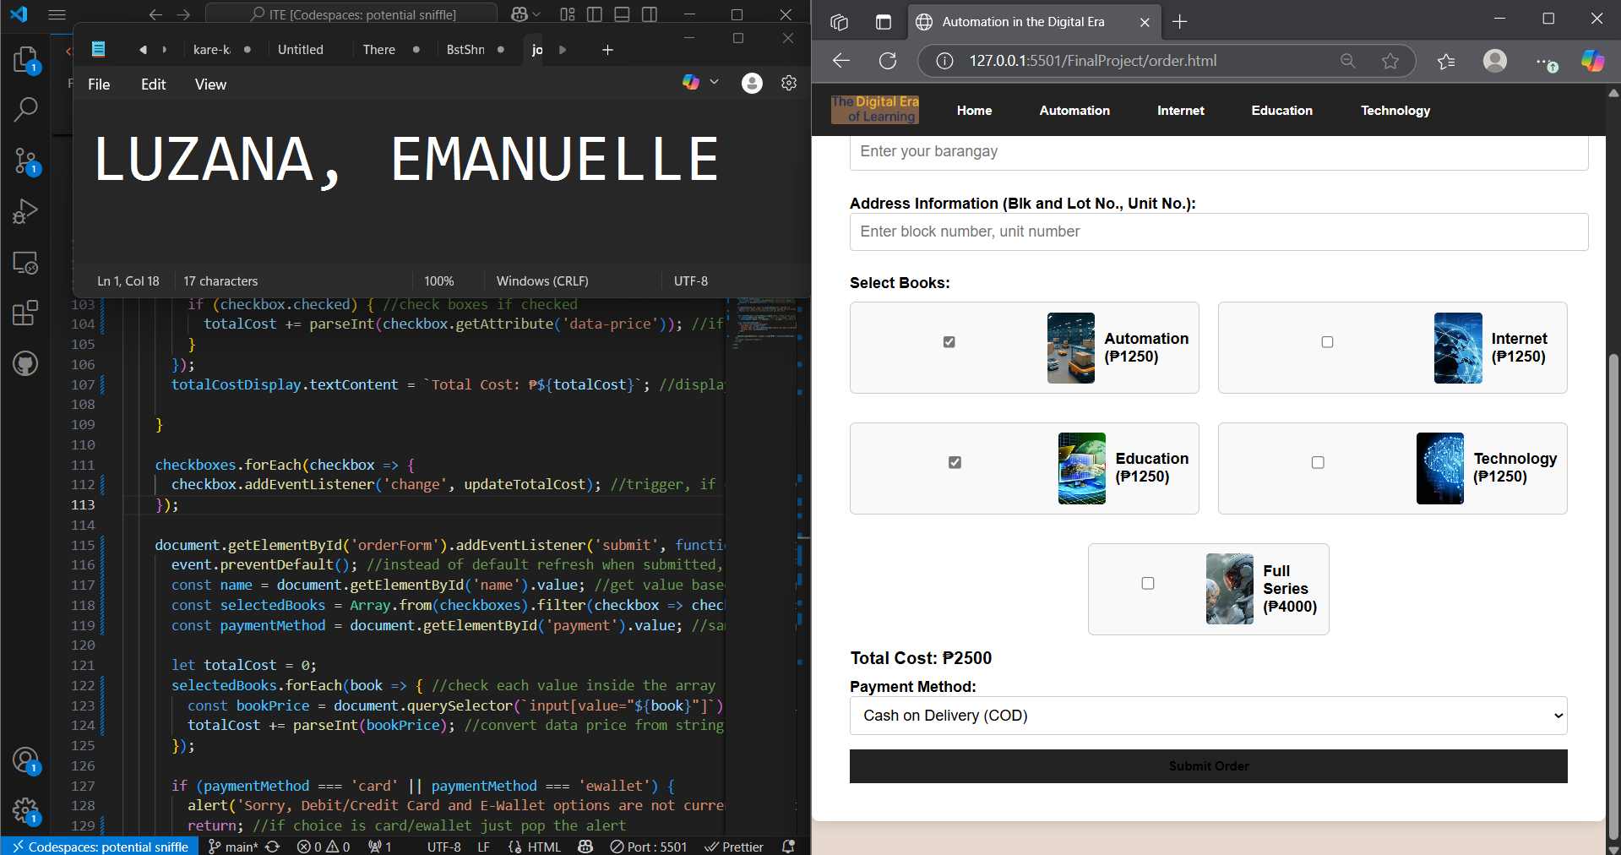

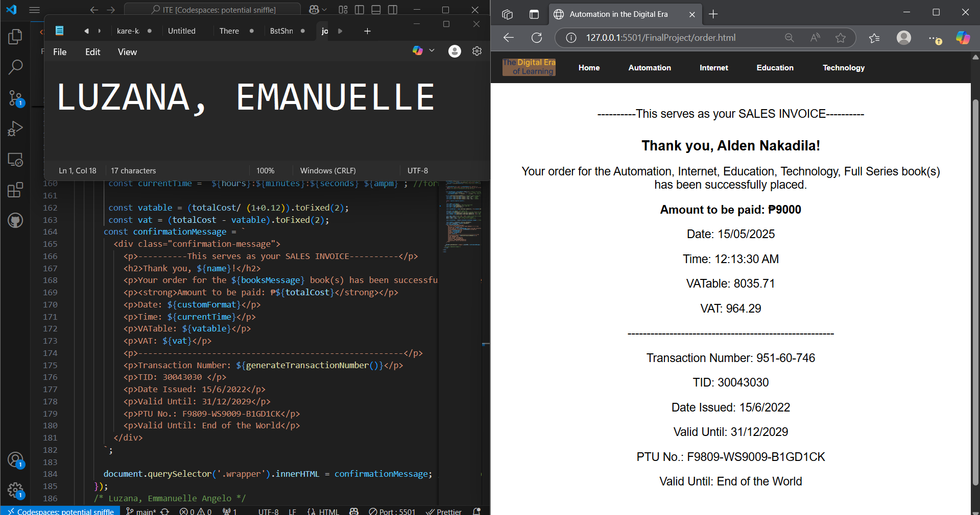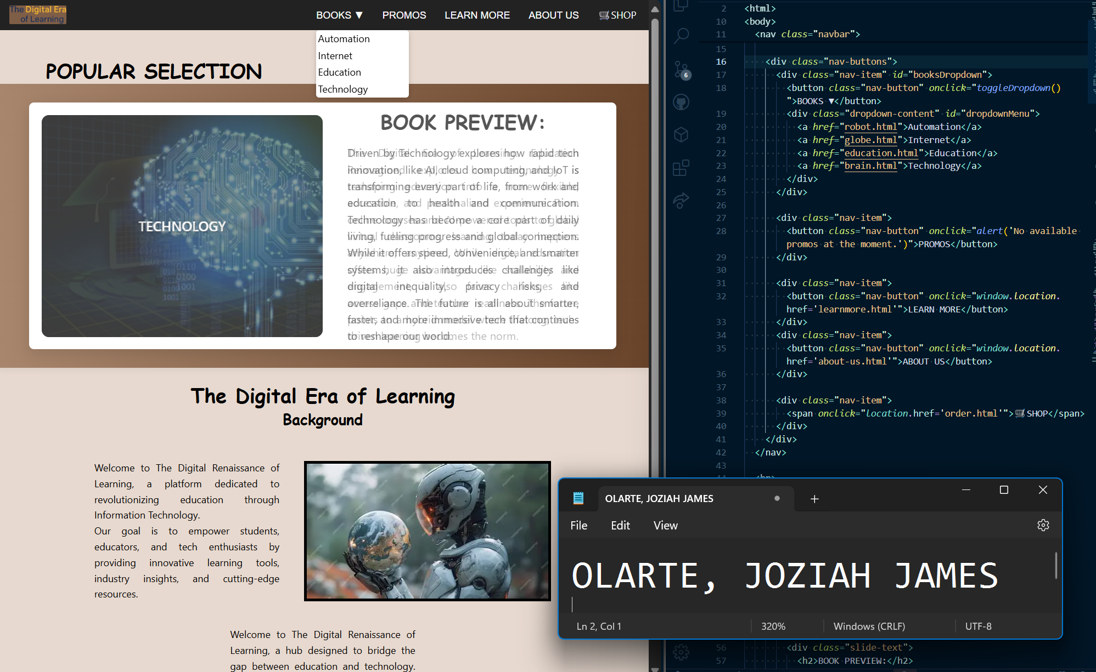

**Extra Pictures:**

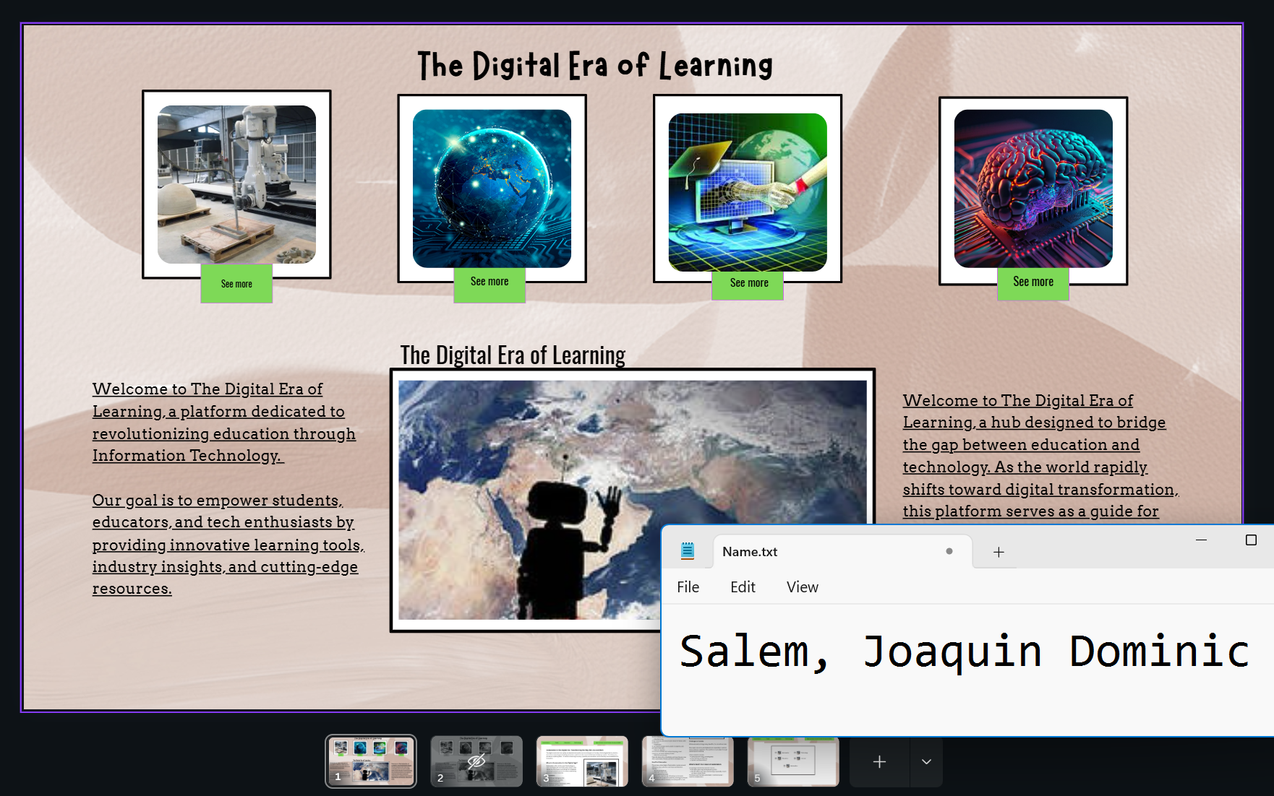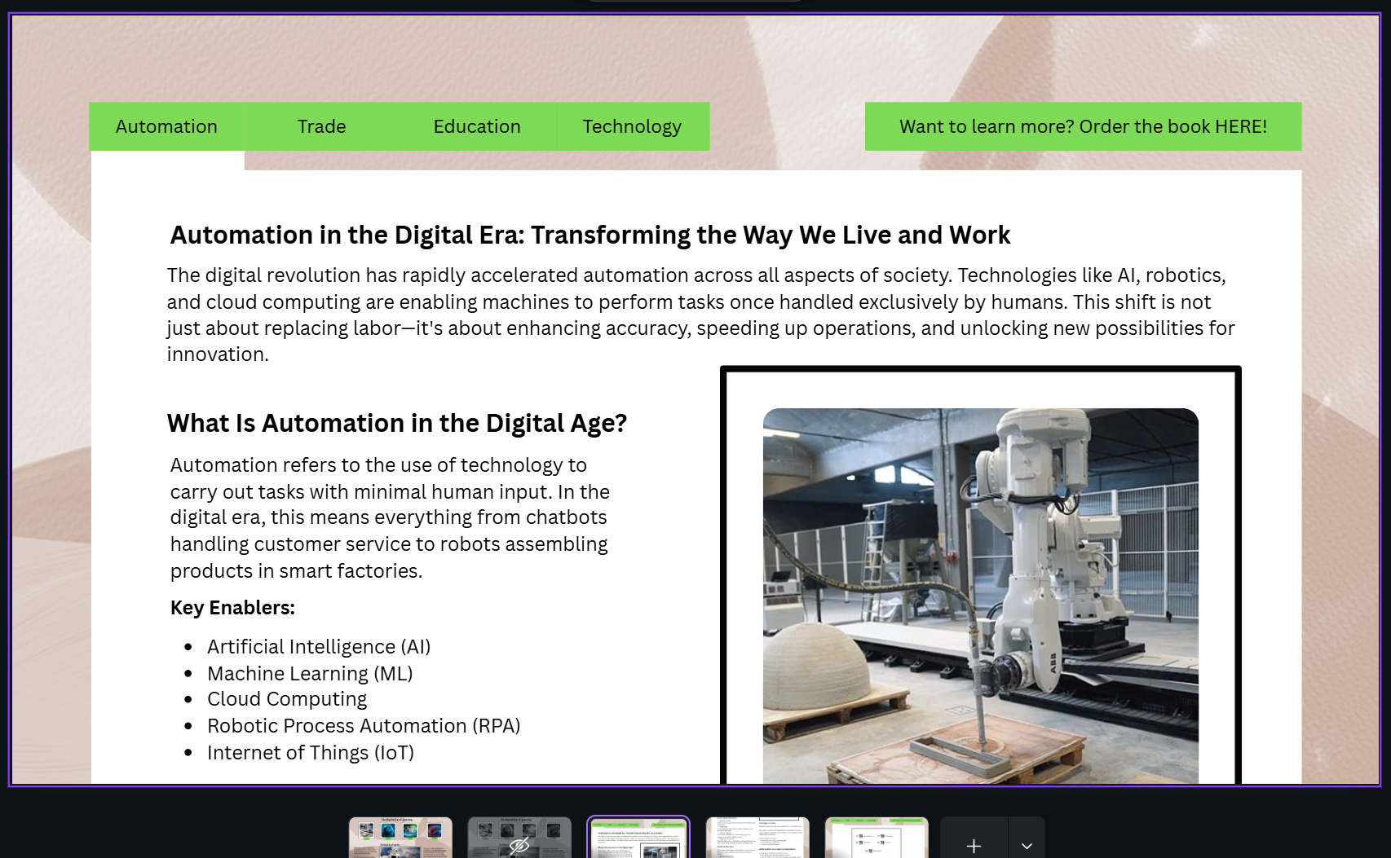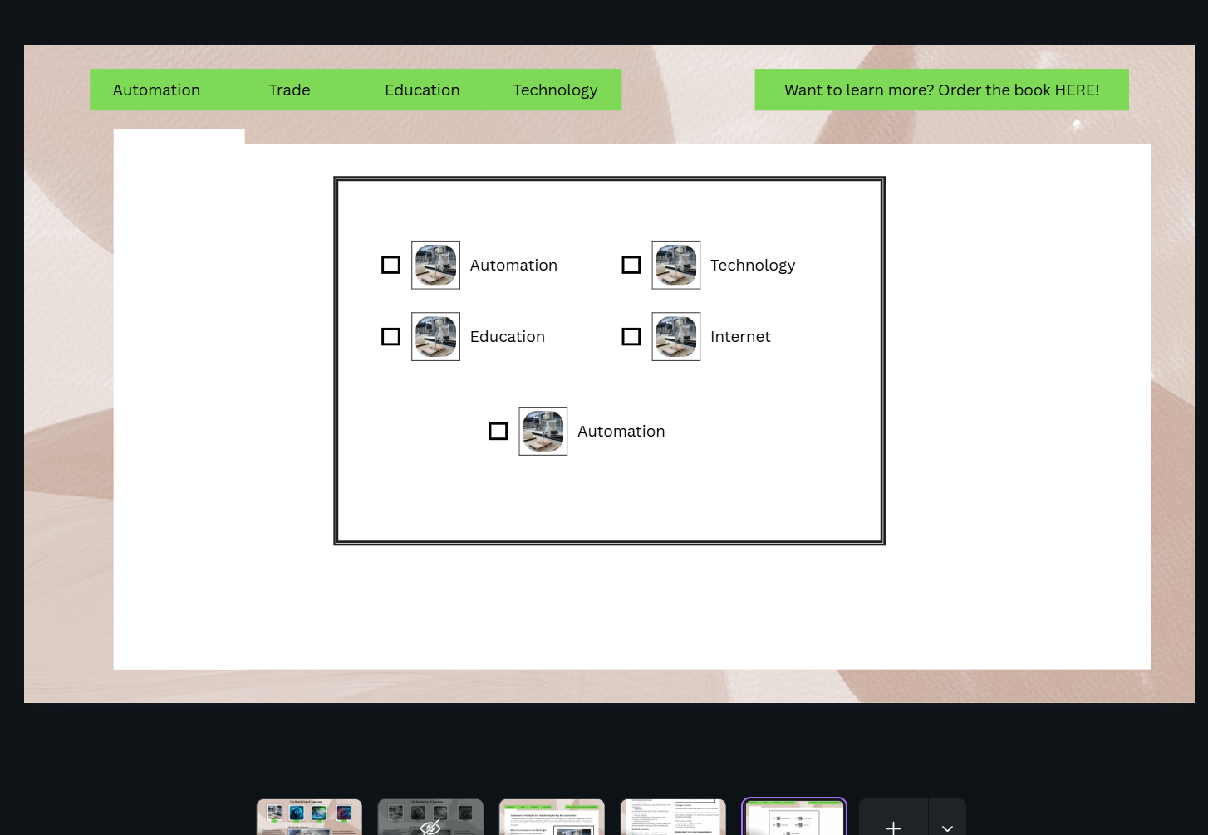

**“We affirm that we shall not give nor receive any unauthorized help on this exam and that all work shall be our own.”**